CS 305 Software Security

Module 6 Coding Assignment

Huan Ai

8/10/2025

C:\个人文件\SNHU\CS305\CS 305 Module Six Code Base\target\dependency-check-report-before.html

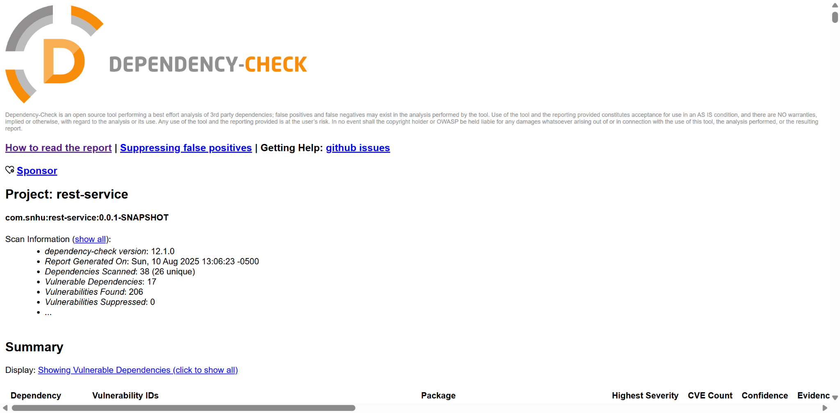

C:\个人文件\SNHU\CS305\CS 305 Module Six Code Base\target\dependency-check-report-after.html

